1- Create VPC with 2 private and 2 public subnets.
Step 1: Created a VPC
First, I opened the Amazon Web Services VPC Dashboard and created a new VPC named My-VPC with the CIDR block 10.0.0.0/16. This created a private network space where all my AWS resources and subnets will exist.

Step 2: Created Two Public Subnets
Next, I created two public subnets inside the VPC:
- Public-Subnet-1 with CIDR 10.0.1.0/24
- Public-Subnet-2 with CIDR 10.0.2.0/24
These subnets were placed in different availability zones for high availability. Public subnets are used for resources that need internet access, such as web servers.

Step 3: Created Two Private Subnets
After that, I created two private subnets:
- Private-Subnet-1 with CIDR 10.0.3.0/24
- Private-Subnet-2 with CIDR 10.0.4.0/24
These were also placed across availability zones. Private subnets are used for secure internal resources like databases and application servers.

Step 4: Enabled Auto Assign Public IP for Public Subnets
I selected both public subnets and enabled Auto-assign Public IPv4 Address. This ensures that any EC2 instance launched inside these public subnets automatically receives a public IP address.

Step 5: Created and Attached an Internet Gateway
I created an Internet Gateway named My-IGW and attached it to My-VPC. This allows resources inside public subnets to communicate with the internet.

Step 6: Created a Public Route Table
I created a route table called Public-RT and added a route:
- 0.0.0.0/0 → Internet Gateway
Then I associated:
- Public-Subnet-1
- Public-Subnet-2
This allows traffic from public subnets to reach the internet.

Step 7: Created a Private Route Table
I created another route table named Private-RT and associated:
- Private-Subnet-1
- Private-Subnet-2
This route table only contains the local VPC route, so private subnets stay isolated from direct internet access.

Step 8: Verified the Architecture
Finally, I checked the VPC, subnets, route tables, and internet gateway to confirm everything was configured correctly.
At the end, I successfully created a production-style VPC architecture with:
- 1 VPC
- 2 Public Subnets
- 2 Private Subnets
- 1 Internet Gateway
- 2 Route Tables
- High Availability across multiple Availability Zones
This setup is commonly used for secure and scalable cloud infrastructure.

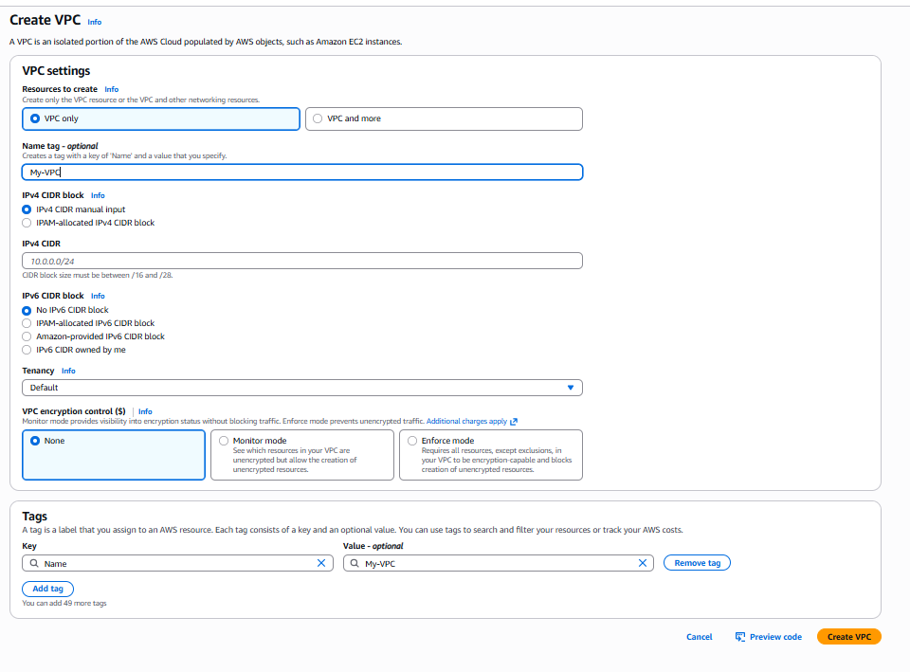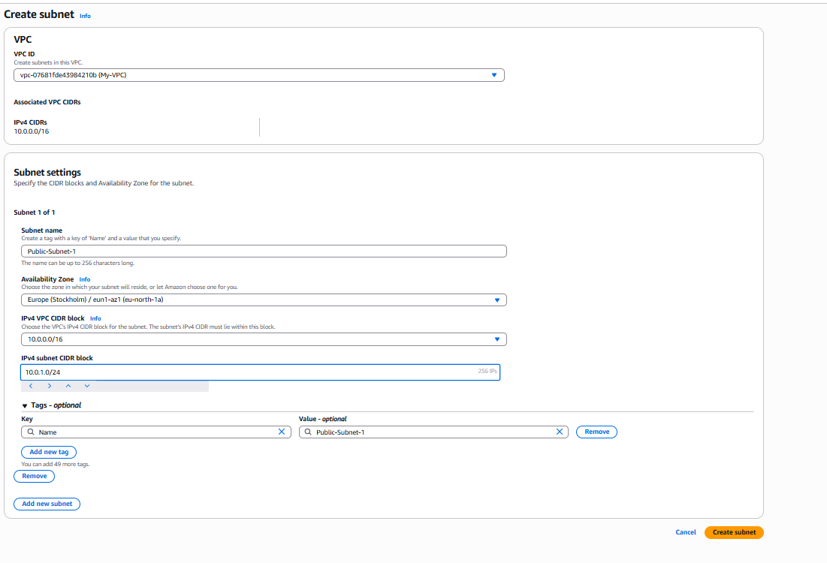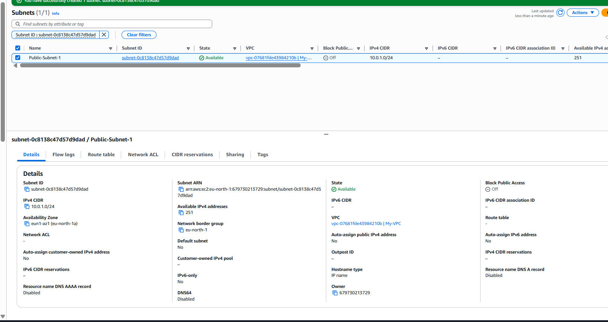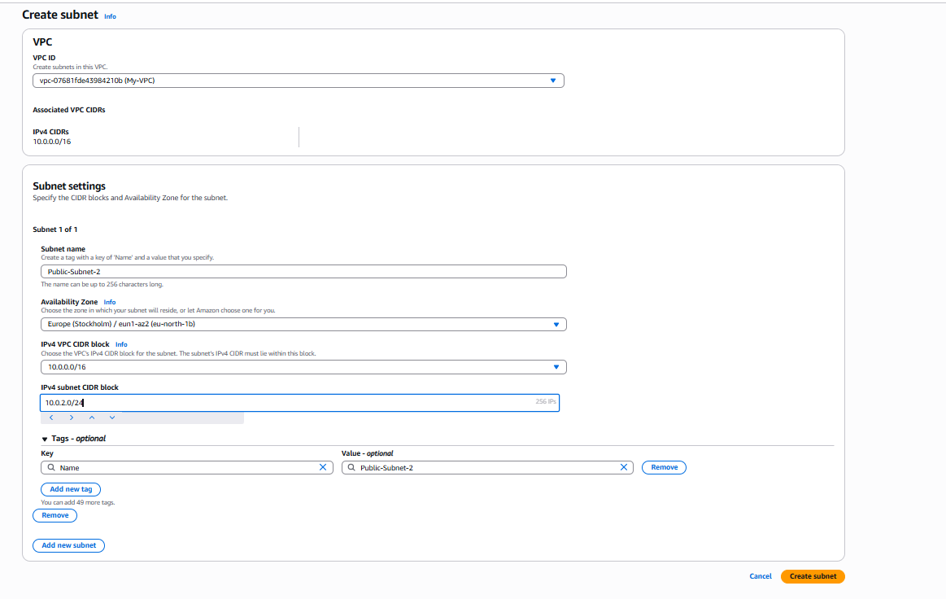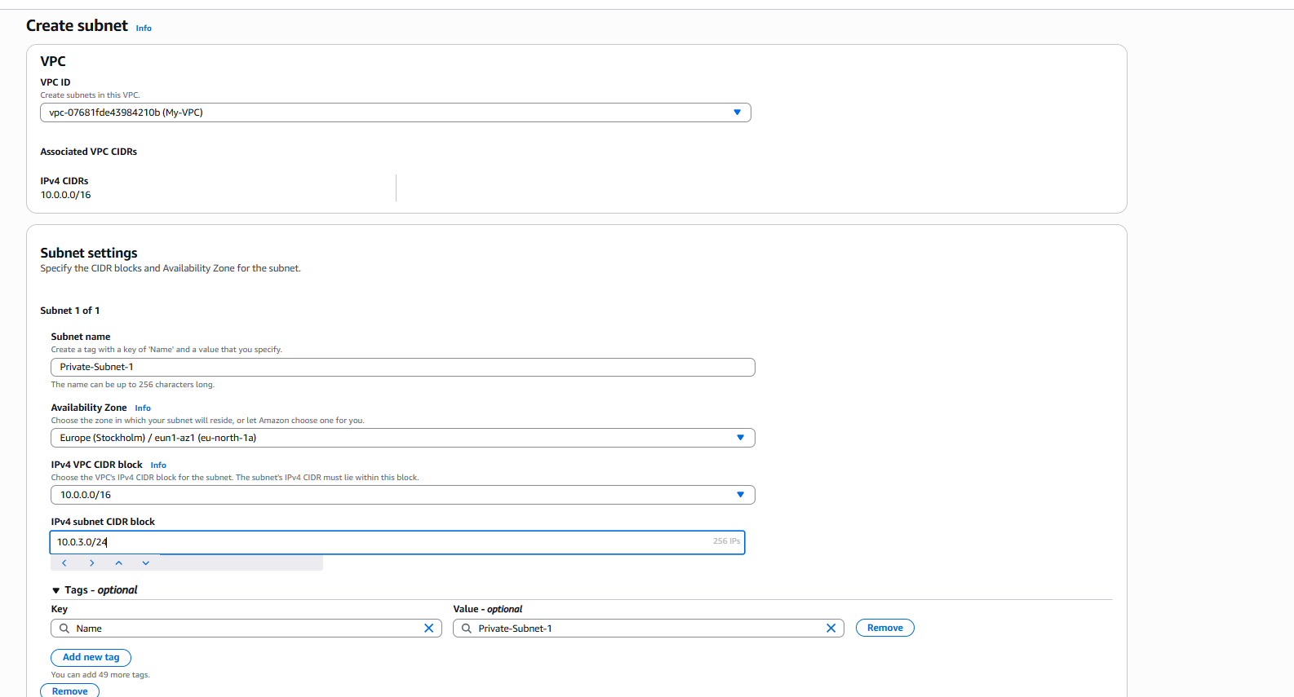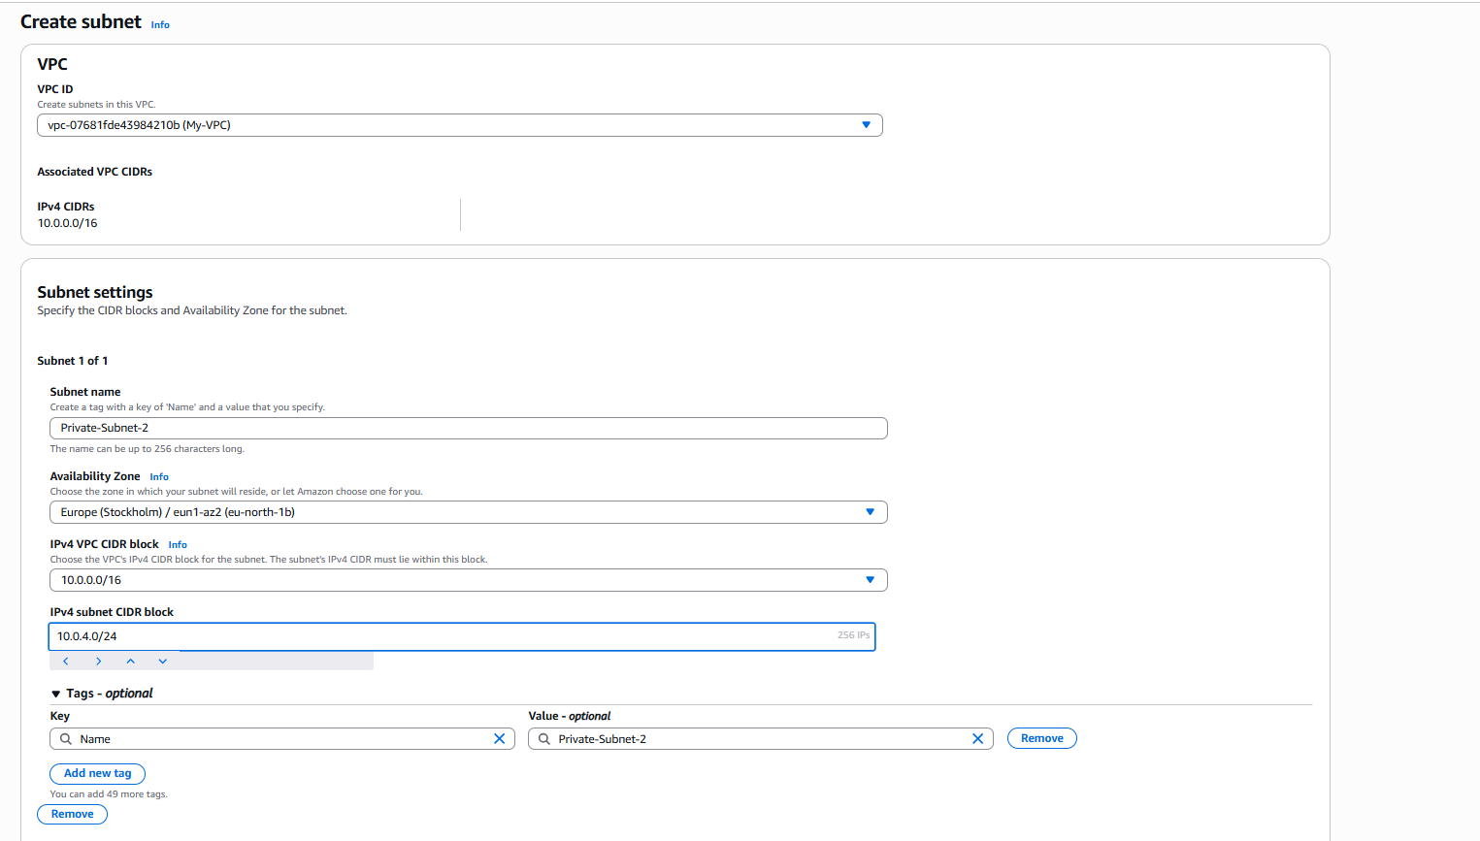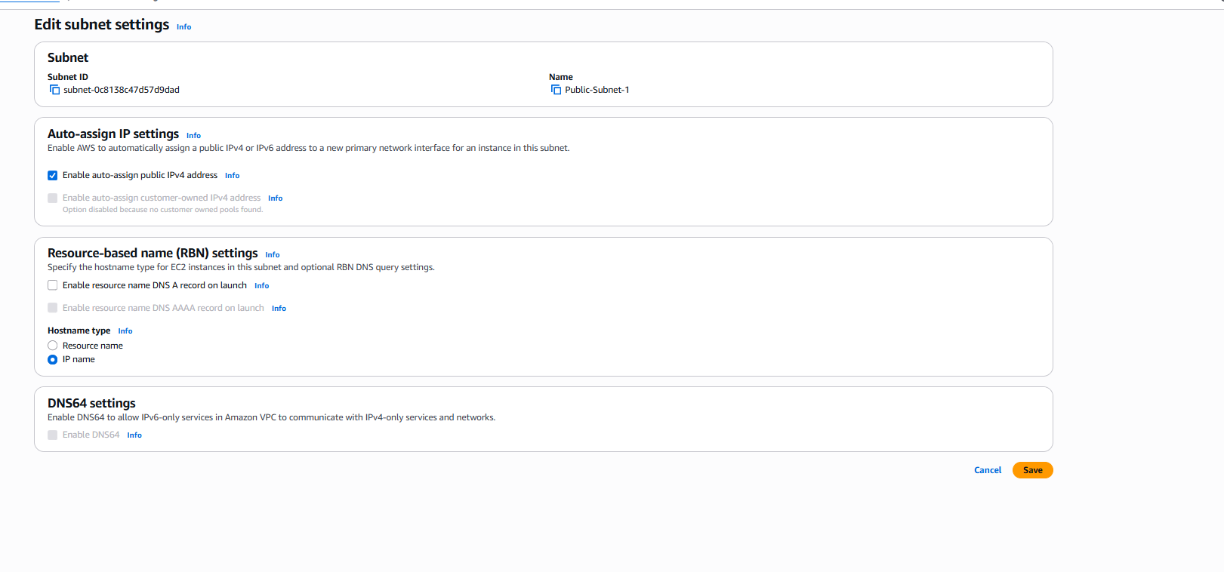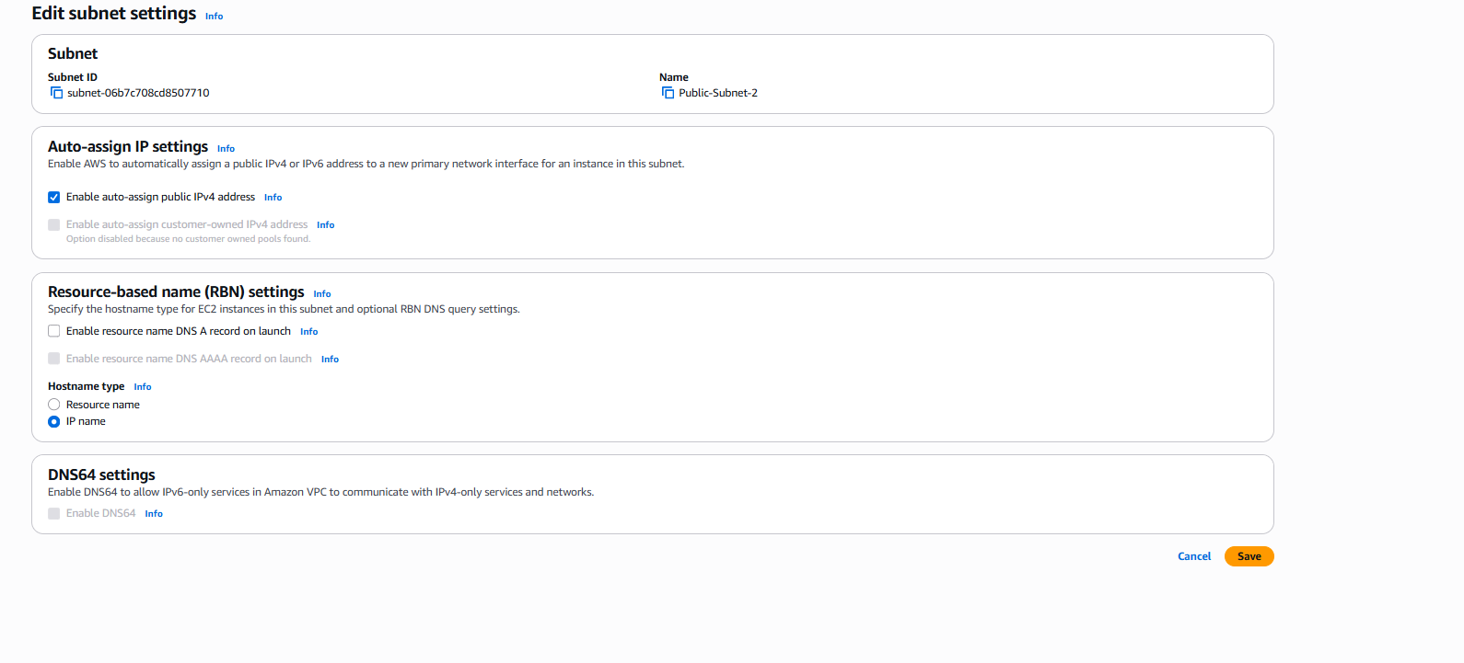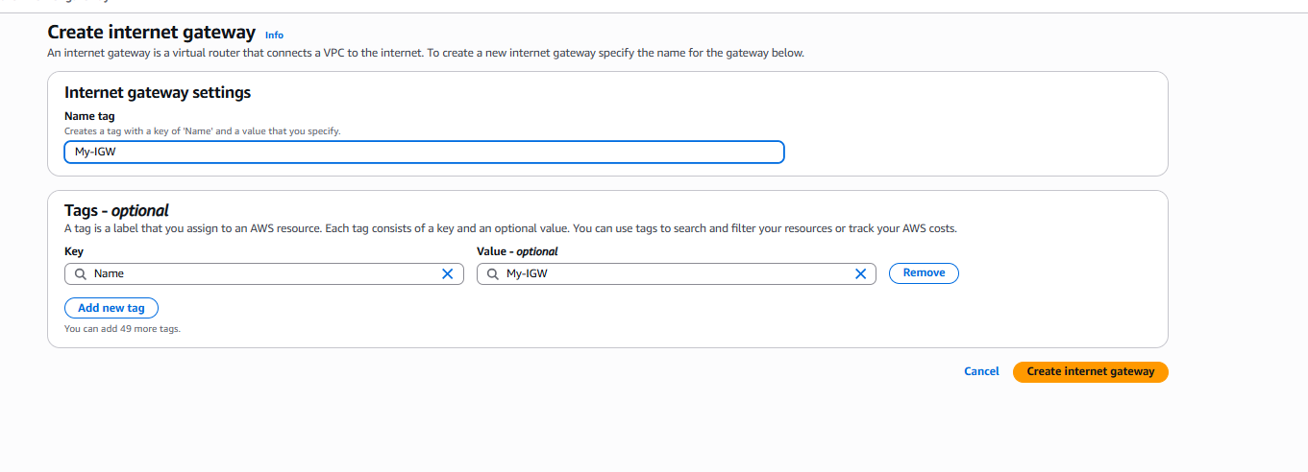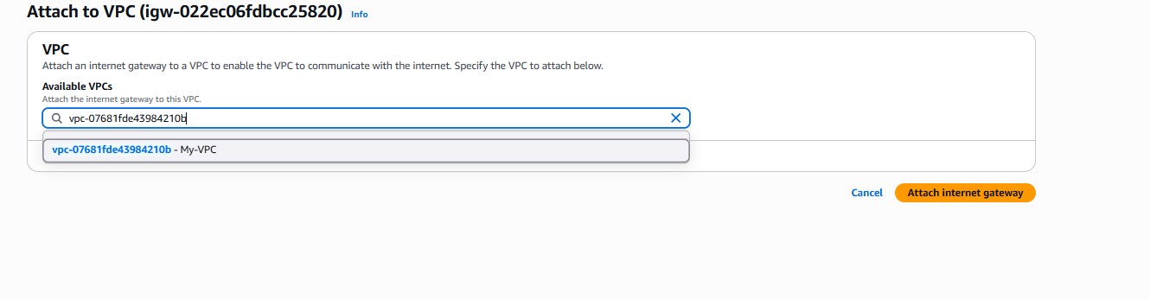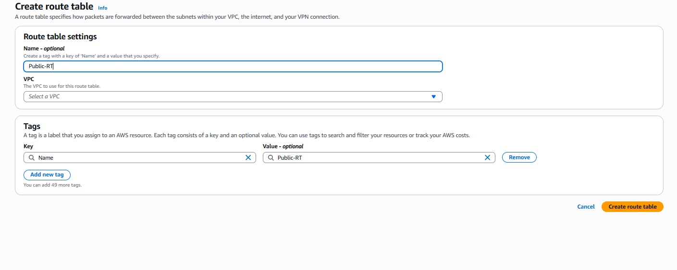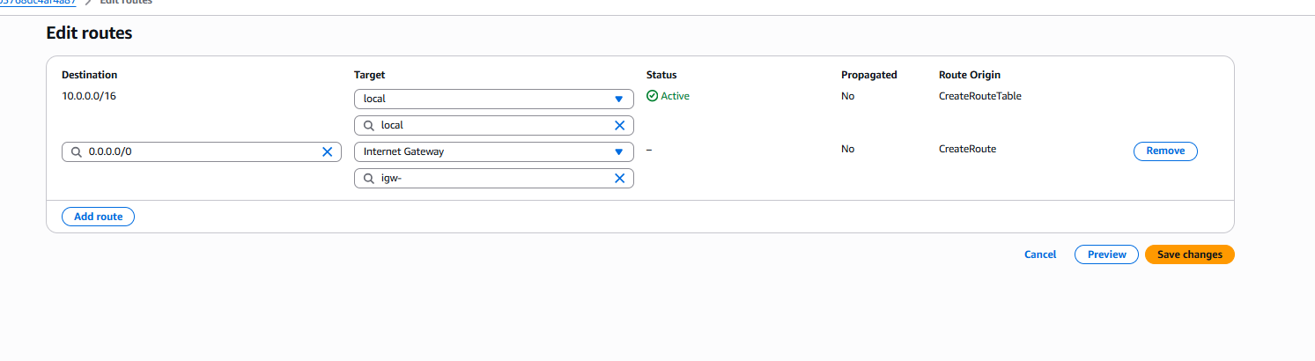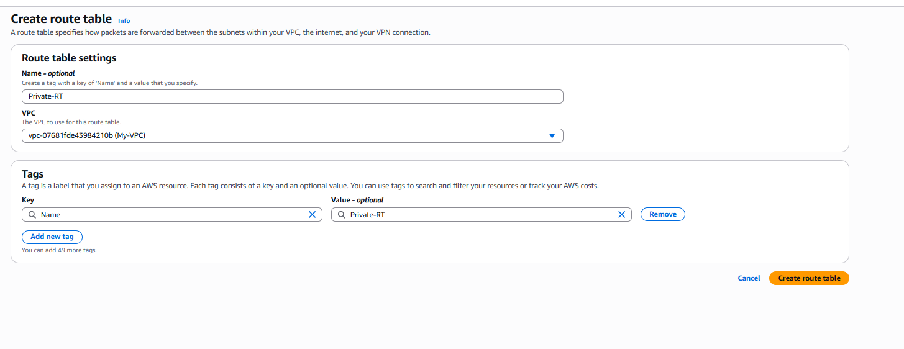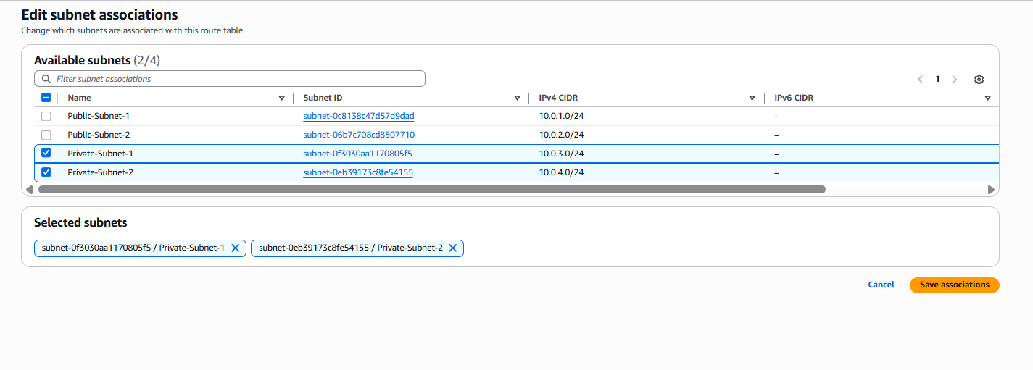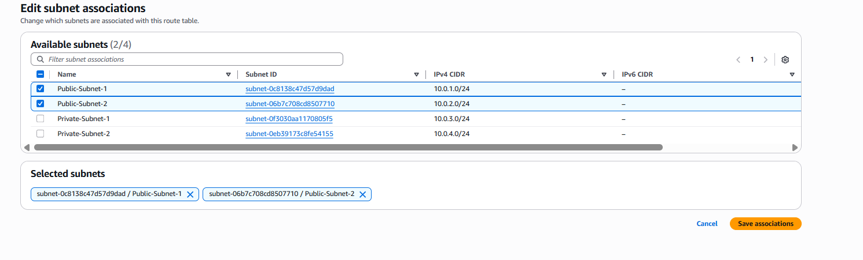

2- Enable DNS Hostname in VPC.

Step 1: Open VPC Dashboard
Login to Amazon Web Services AWS Console and open VPC Dashboard.

Step 2: Go to Your VPCs
On the left menu, click Your VPCs.
This page shows all the VPCs created in your account.

Step 3: Select Your VPC
Select your VPC: My-VPC
This is the VPC where DNS hostname needs to be enabled.

Step 4: Open Actions Menu
Click Actions at the top.
A dropdown menu will appear.

Step 5: Edit VPC Settings
Click Edit VPC settings
This opens network settings for the selected VPC.

Step 6: Enable DNS Hostnames
You will see options like:
✔ Enable DNS resolution
✔ Enable DNS hostnames
Make sure Enable DNS hostnames is checked.
Then click Save

Step 7: Verify
After saving, open VPC details and check:
- DNS Resolution: Enabled
- DNS Hostnames: Enabled

Description (What you did)
I selected my VPC and enabled DNS Hostnames in the VPC settings. This allows EC2 instances launched inside the VPC to receive public DNS names, making it easier to connect to instances using hostnames instead of IP addresses. This is important for internet-facing resources and proper network communication.

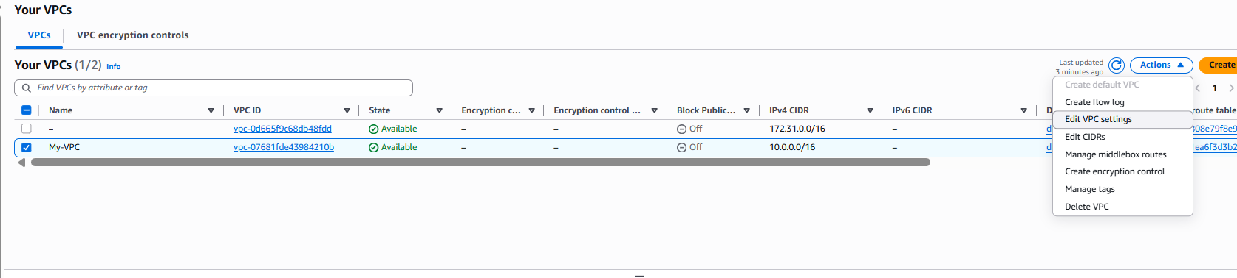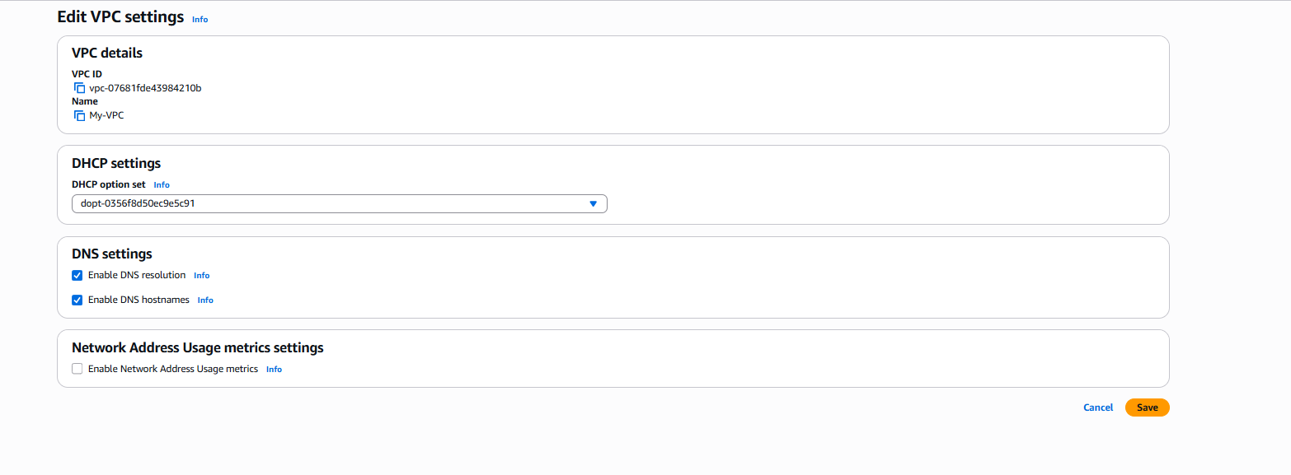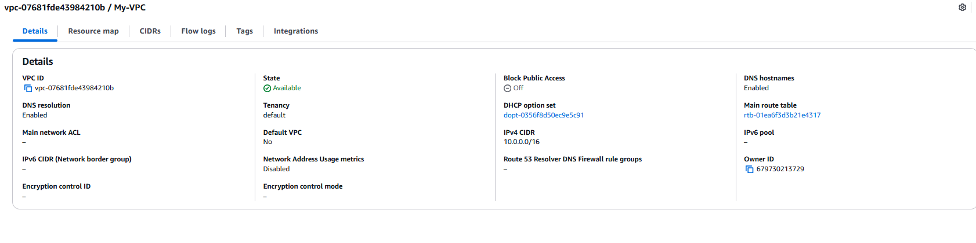

3- Enable Auto Assign Public IP in 2 public subnets.
Step 1: Open VPC Dashboard
Login to Amazon Web Services AWS Console and open VPC Dashboard.

Step 2: Open Subnets
From the left menu, click Subnets.
This page shows all the subnets created inside your VPC.

Step 3: Select Public-Subnet-1
Find and select Public-Subnet-1

Step 4: Edit Subnet Settings
Click Actions → Edit subnet settings

Step 5: Enable Auto Assign Public IPv4
Check:
✔ Enable auto-assign public IPv4 address
Click Save
This ensures any EC2 launched in this subnet automatically gets a public IP.

Step 6: Repeat for Public-Subnet-2
Now select Public-Subnet-2
Again go to:
Actions → Edit subnet settings
Check:
✔ Enable auto-assign public IPv4 address
Click Save

Step 7: Verify
Open both public subnets and check subnet settings.
You should see:
Auto-assign public IPv4: Enabled

Description (What you did)
I selected both public subnets and enabled Auto Assign Public IPv4 Address. This allows EC2 instances launched inside these public subnets to automatically receive public IP addresses, making them accessible from the internet. This is required for public-facing resources like web servers.

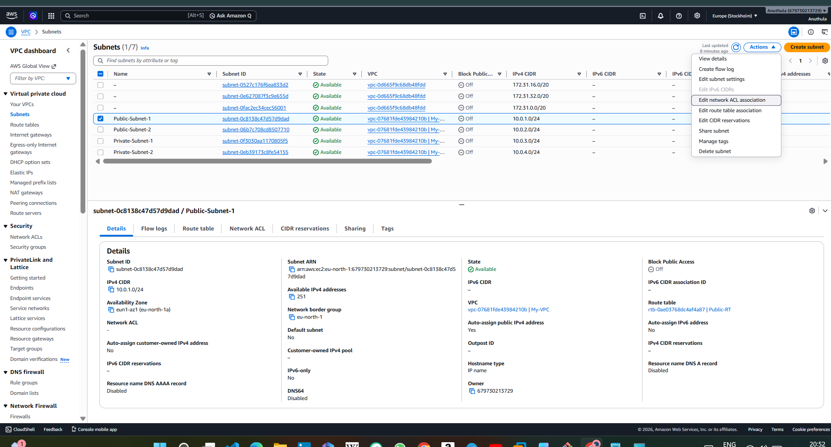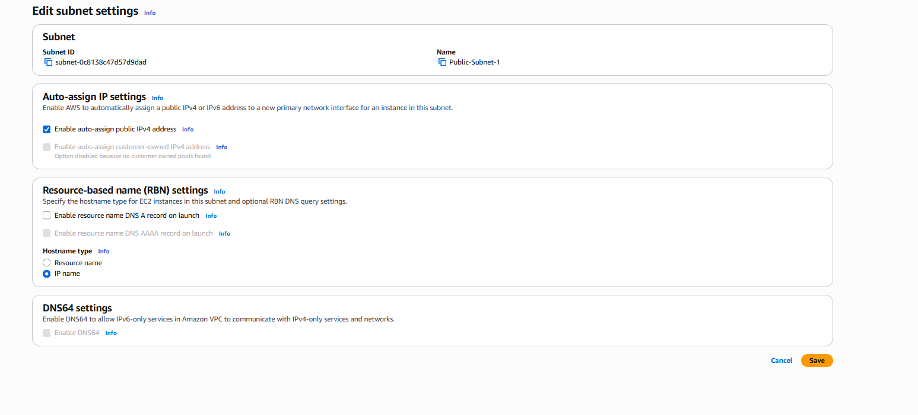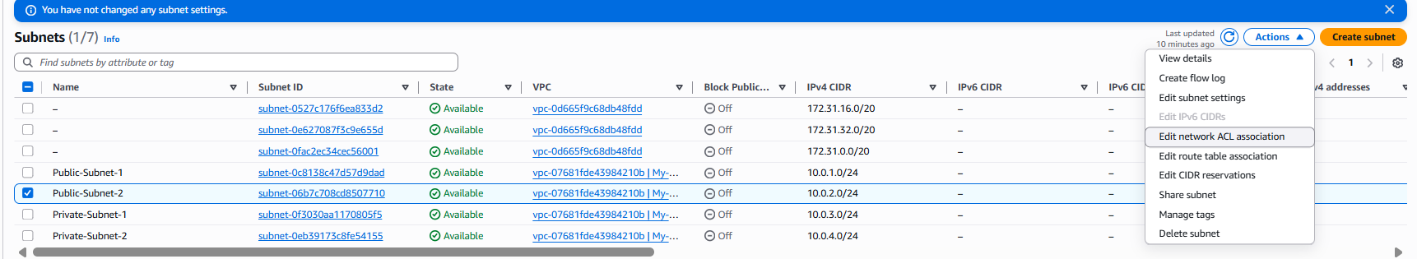

4- Add 2 private subnets in private route table.
Step 1: Opened VPC Dashboard
First, I logged in to the Amazon Web Services AWS Console and opened the VPC Dashboard to manage my network resources.

Step 2: Opened Route Tables
From the left-side menu, I selected Route Tables to view all route tables created inside my VPC.

Step 3: Selected the Private Route Table
I selected the route table named Private-RT, which is used for private network routing inside the VPC.

Step 4: Opened Subnet Associations
After selecting the private route table, I opened the Subnet Associations tab to check which subnets were connected to it.

Step 5: Edited Subnet Associations
I clicked Edit subnet associations to modify the subnets associated with the private route table.

Step 6: Selected Private Subnets
I selected:
- Private-Subnet-1
- Private-Subnet-2
This ensures both private subnets use this route table.

Step 7: Saved the Associations
After selecting the private subnets, I clicked Save associations to apply the changes.

Step 8: Verified the Configuration
Finally, I verified that both private subnets were successfully associated with the private route table.

Final Description
By associating Private-Subnet-1 and Private-Subnet-2 with Private-RT, I ensured these subnets follow private routing rules and remain isolated from direct internet access. This is useful for secure internal services such as databases and backend application servers.

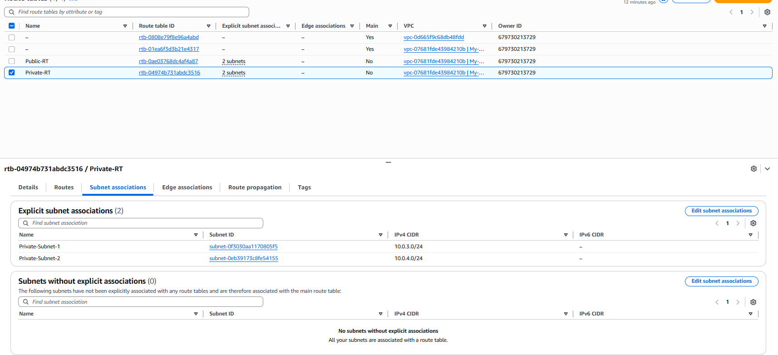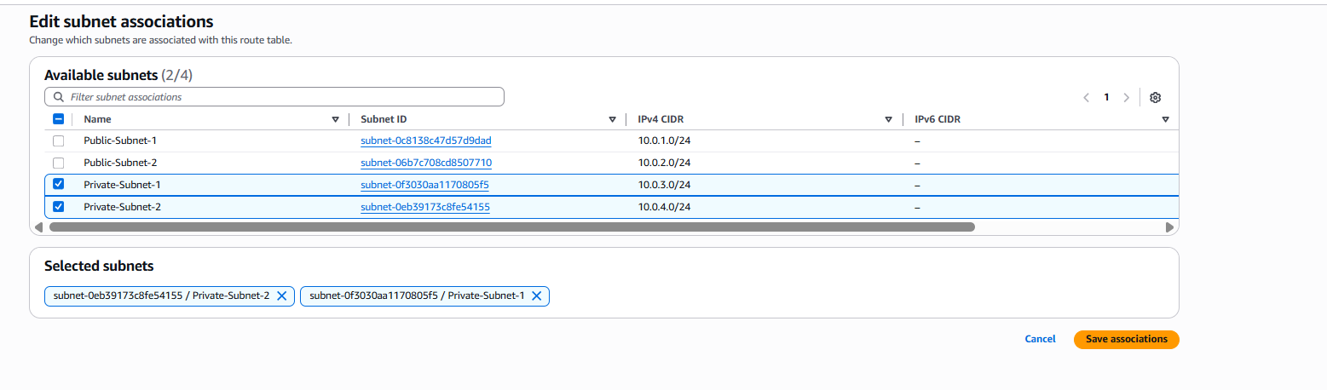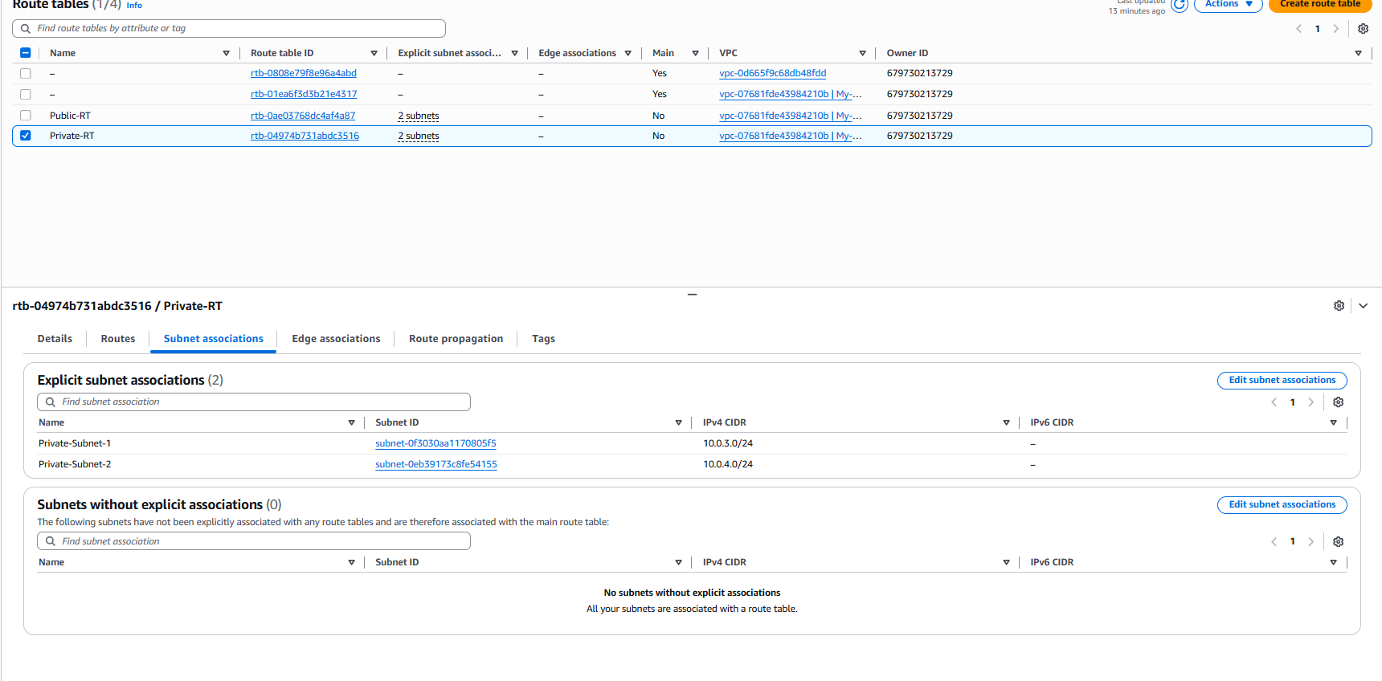
5- Add 2 public subnets in public route table.
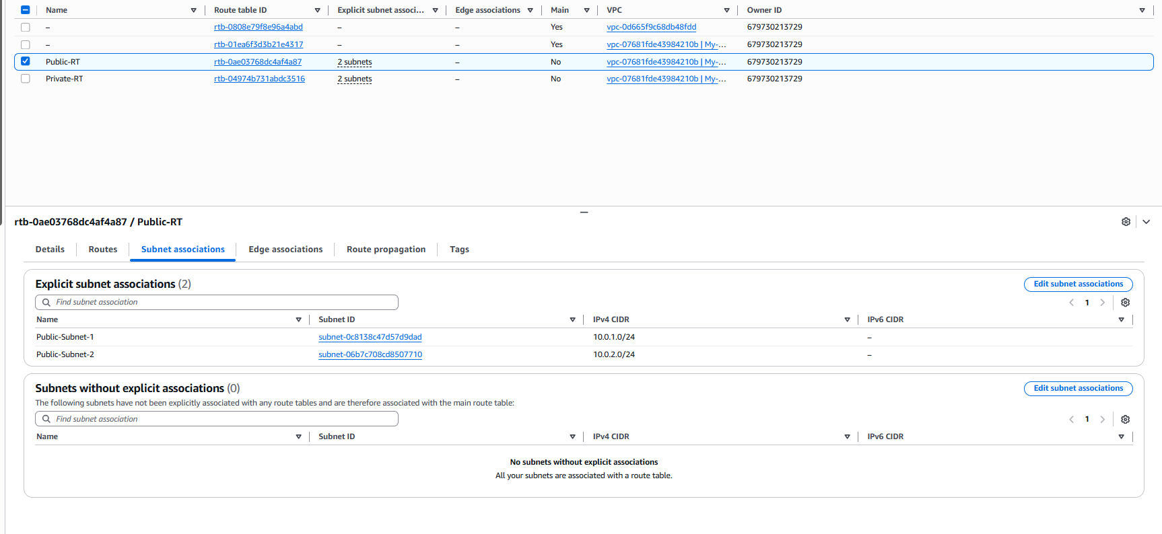

Step 1: Opened VPC Dashboard
First, I logged in to the Amazon Web Services AWS Console and opened the VPC Dashboard to manage my network resources.

Step 2: Opened Route Tables
From the left-side menu, I selected Route Tables to view all route tables created inside my VPC.

Step 3: Selected the Public Route Table
I selected the route table named Public-RT, which is used for routing internet traffic for public subnets.

Step 4: Opened Subnet Associations
After selecting the public route table, I opened the Subnet Associations tab to check which subnets were connected to it.

Step 5: Edited Subnet Associations
I clicked Edit subnet associations to modify the subnets associated with the public route table.

Step 6: Selected Public Subnets
I selected:
- Public-Subnet-1
- Public-Subnet-2
This ensures both public subnets use this route table.

Step 7: Saved the Associations
After selecting the public subnets, I clicked Save associations to apply the changes.

Step 8: Verified the Configuration
Finally, I verified that both public subnets were successfully associated with the public route table.

Final Description
By associating Public-Subnet-1 and Public-Subnet-2 with Public-RT, I ensured these subnets follow public routing rules and can send internet traffic through the Internet Gateway. This allows instances launched in these subnets to access the internet and be publicly reachable when assigned a public IP address.

6- Public route table will have the routes to internet and local.
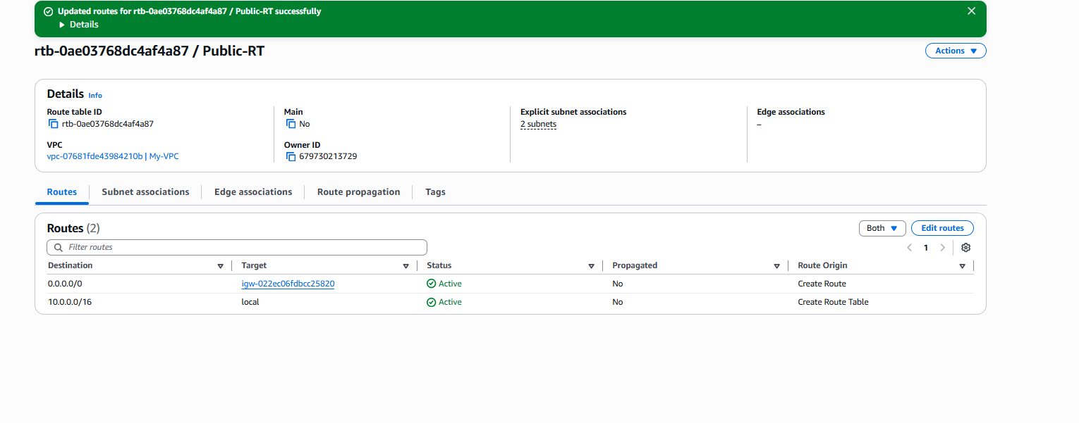
1 Step 1: Opened VPC Dashboard
First, I logged in to the Amazon Web Services AWS Console and opened the VPC Dashboard to manage networking resources.

Step 2: Opened Route Tables
From the left-side menu, I selected Route Tables to view all route tables created inside my VPC.

Step 3: Selected the Public Route Table
I selected the route table named Public-RT, which controls routing for public subnets.

Step 4: Opened Routes Tab
After selecting the route table, I opened the Routes tab to view existing routes.

Step 5: Verified Local Route
I verified the local route:
Destination: 10.0.0.0/16
Target: local
This route allows communication between all subnets inside the VPC.

Step 6: Added Internet Route
I added another route:
Destination: 0.0.0.0/0
Target: Internet Gateway (My-IGW)
This route sends internet traffic outside the VPC through the internet gateway.

Step 7: Saved the Route
After entering the route details, I clicked Save routes to apply the configuration.

Step 8: Verified Both Routes
Finally, I confirmed that the public route table contains:
- 10.0.0.0/16 → local
- 0.0.0.0/0 → Internet Gateway

Final Description
The public route table contains two routes: a local route for communication within the VPC and an internet route that sends external traffic to the Internet Gateway. This allows resources in public subnets to communicate internally and access the internet.

7- Create EC2 in public subnet with t2.micro and install PHP.
Create EC2 in public subnet with t2.micro and install PHP
Step 1: Opened EC2 Dashboard
First, I logged in to the Amazon Web Services AWS Console and opened the EC2 Dashboard to create a new virtual server.

Step 2: Started Launching an Instance
I clicked Launch Instance to start creating a new EC2 instance.

Step 3: Entered Instance Name
I entered the instance name as PHP-Server to easily identify the server.

Step 4: Selected Amazon Linux AMI
I selected Amazon Linux as the operating system image for the instance. This provides a Linux-based environment supported by AWS.

Step 5: Selected Instance Type
I selected t2.micro as the instance type.
This is a lightweight and cost-effective instance suitable for small applications and testing.

Step 6: Selected Key Pair
I selected my key pair for secure SSH access to the EC2 instance.

Step 7: Configured Network Settings
Under network settings, I selected:
- VPC: My-VPC
- Subnet: Public-Subnet-1
- Auto Assign Public IP: Enabled
This ensures the instance is launched in the public subnet with internet access.

Step 8: Configured Security Group
I configured firewall rules by allowing:
- SSH (Port 22) for remote access
- HTTP (Port 80) for web traffic
This allows secure login and web access to the server.

Step 9: Launched the Instance
After completing the configuration, I clicked Launch Instance to create the EC2 server.

Step 10: Connected to the EC2 Instance
After the instance was running, I connected to it remotely using SSH through the terminal.

Step 11: Installed PHP
I installed PHP using the command:
sudo yum install php -y
This downloaded and installed PHP successfully.

Step 12: Verified PHP Installation
Finally, I verified the installation using:
php -v
The output confirmed that PHP was successfully installed.

Final Description
I successfully created an EC2 instance in the public subnet using the t2.micro instance type, configured internet access and security rules, connected to it securely using SSH, installed PHP, and verified the installation. The server is now ready to host PHP-based applications.

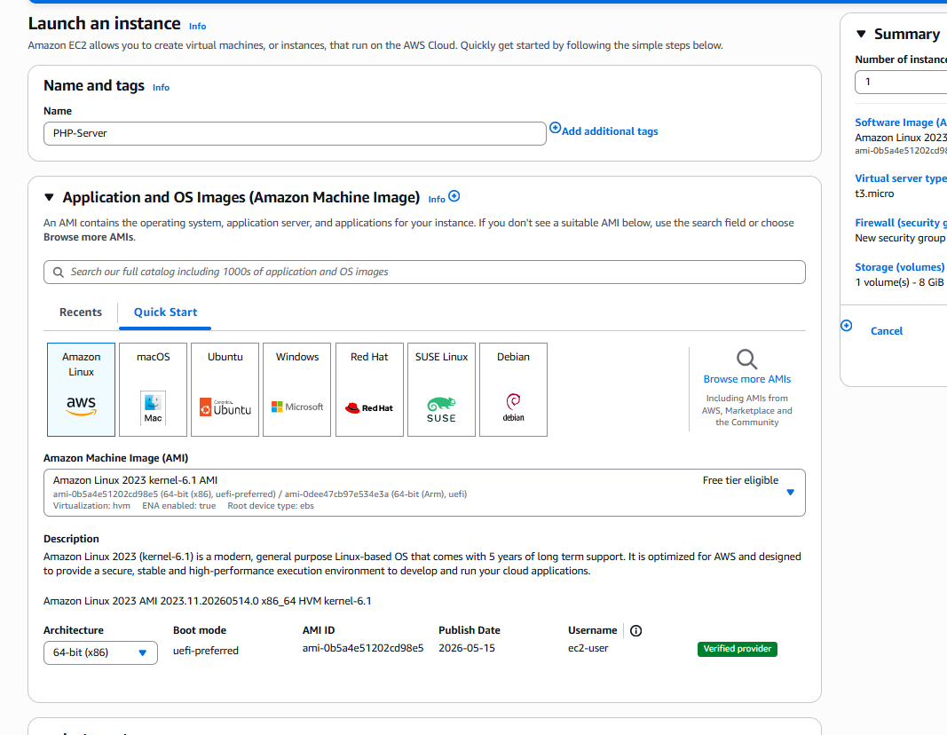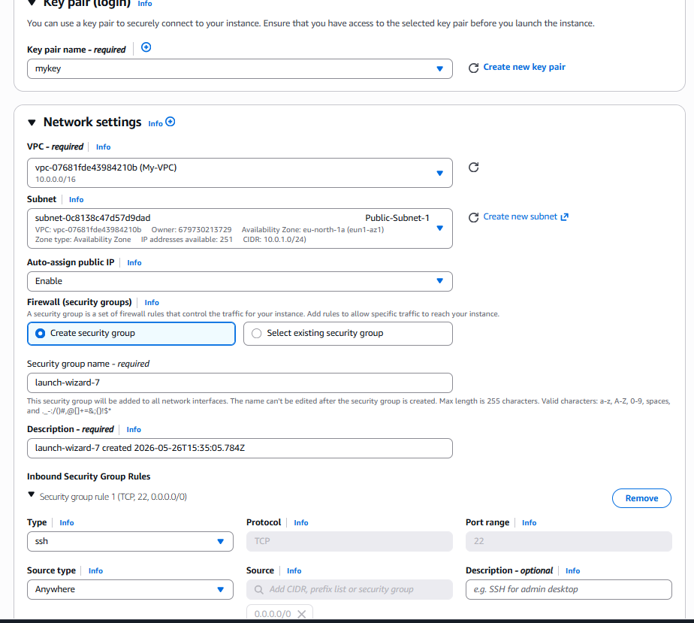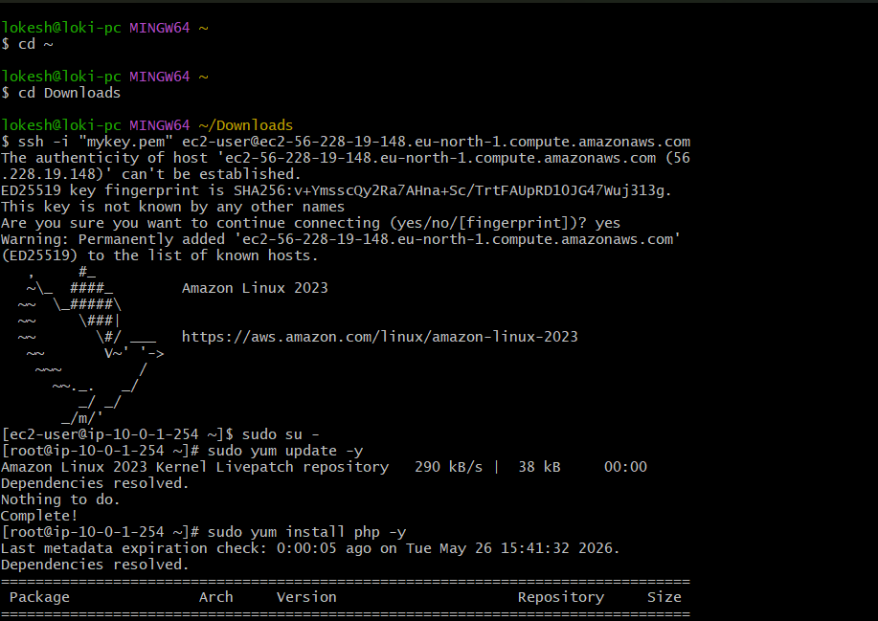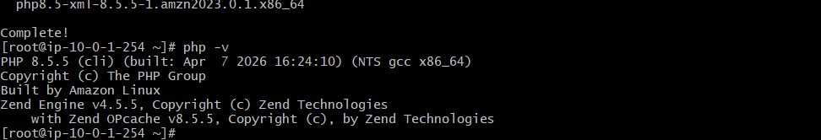

8- Configure NAT gateway in public subnet and connect to private instance. 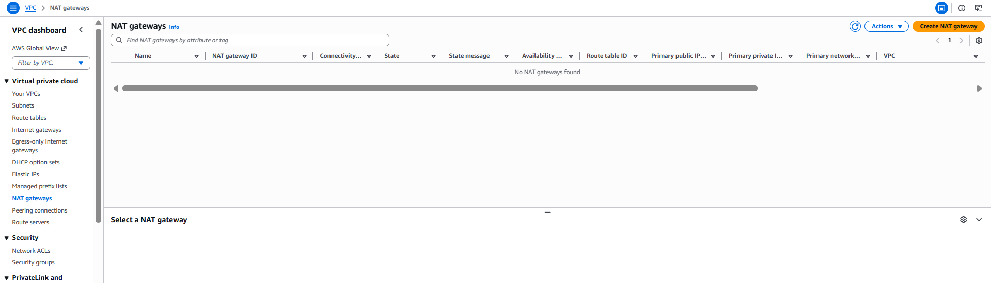 Configure NAT Gateway in public subnet and connect to private instance
Step 1: Opened VPC Dashboard
First, I logged in to the Amazon Web Services AWS Console and opened the VPC Dashboard to configure private internet access.

Step 2: Opened NAT Gateways
From the left-side menu, I selected NAT Gateways to create a new NAT gateway.

Step 3: Created NAT Gateway
I clicked Create NAT Gateway.
Then I entered:
- Name: My-NAT
- Subnet: Public-Subnet-1
This places the NAT Gateway inside the public subnet.

Step 4: Allocated Elastic IP
I clicked Allocate Elastic IP
This assigned a public static IP address to the NAT Gateway so it can access the internet.

Step 5: Created NAT Gateway
After selecting the Elastic IP, I clicked Create NAT Gateway
AWS then created the NAT Gateway.
I waited until its status changed to Available.

Step 6: Opened Private Route Table
After NAT creation, I opened Route Tables and selected:
Private-RT
This route table controls private subnet traffic.

Step 7: Edited Private Route Routes
I opened the Routes tab and clicked Edit Routes
Then clicked Add Route
Entered:
- Destination: 0.0.0.0/0
- Target: NAT Gateway
- Selected: My-NAT

Step 8: Saved Route Changes
I clicked Save changes
This allows private subnets to access the internet through the NAT Gateway.

Step 9: Launched Private EC2 Instance
I launched another EC2 instance and selected:
- VPC: My-VPC
- Subnet: Private-Subnet-1
- Auto Assign Public IP: Disabled
This placed the instance inside the private subnet.

Step 10: Connected Through Public Instance
I first connected to the public EC2 instance using SSH.
Then from the public instance, I connected to the private EC2 instance using its private IP address.
This allows secure access to private resources.

Step 11: Verified Internet Access from Private Instance
Inside the private instance, I tested internet access:
ping google.com
The response confirmed the private instance was accessing the internet through the NAT Gateway.

Final Description
I created a NAT Gateway inside the public subnet, attached an Elastic IP, updated the private route table to route internet traffic through the NAT Gateway, launched a private EC2 instance, connected to it through the public EC2 instance, and verified internet connectivity. This setup allows private instances to securely access the internet without being directly exposed to the public network.
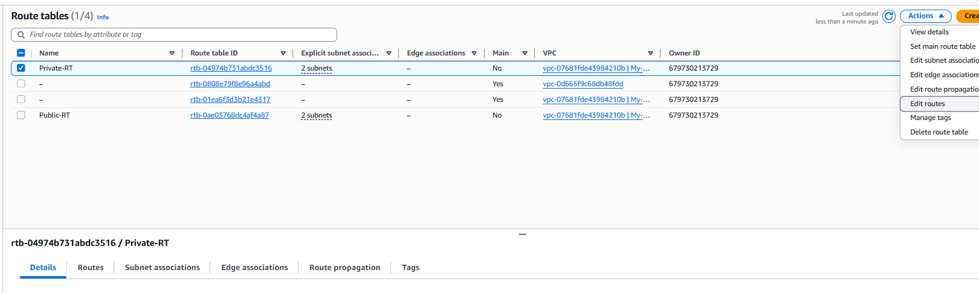
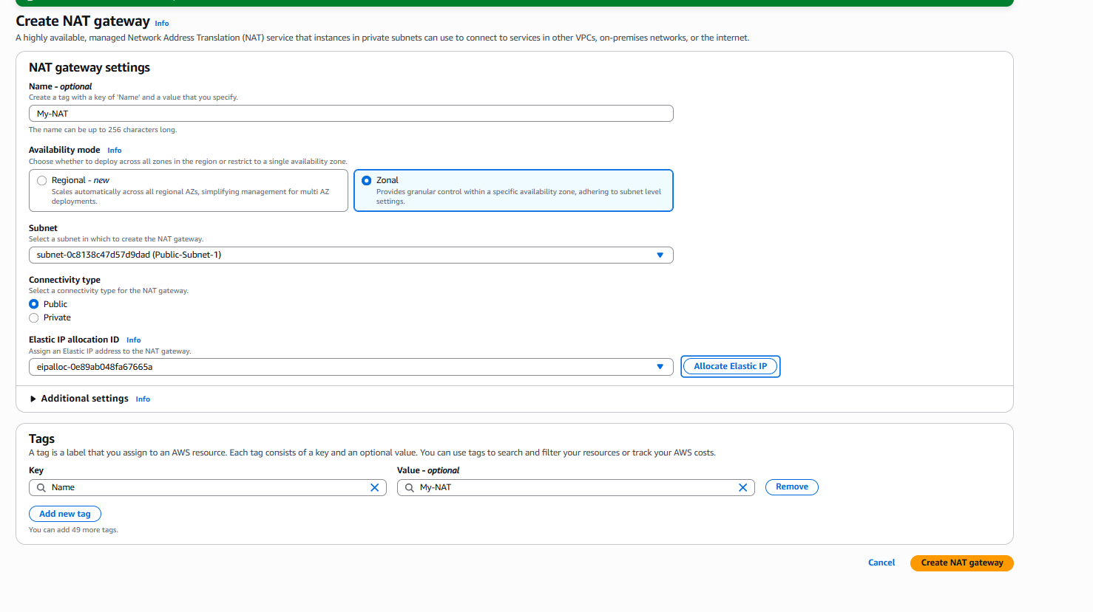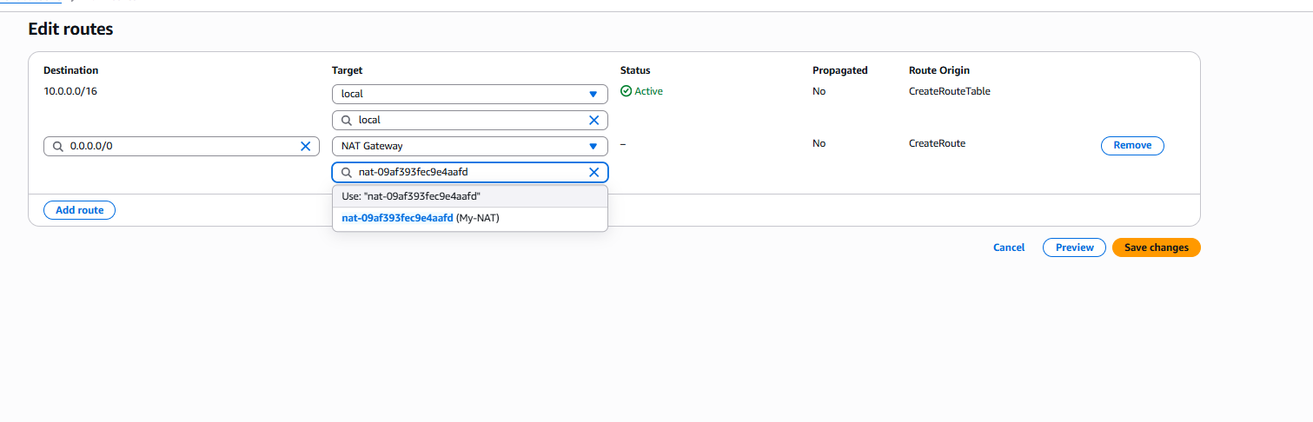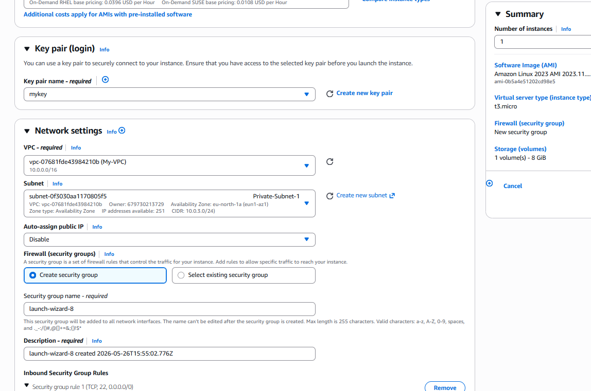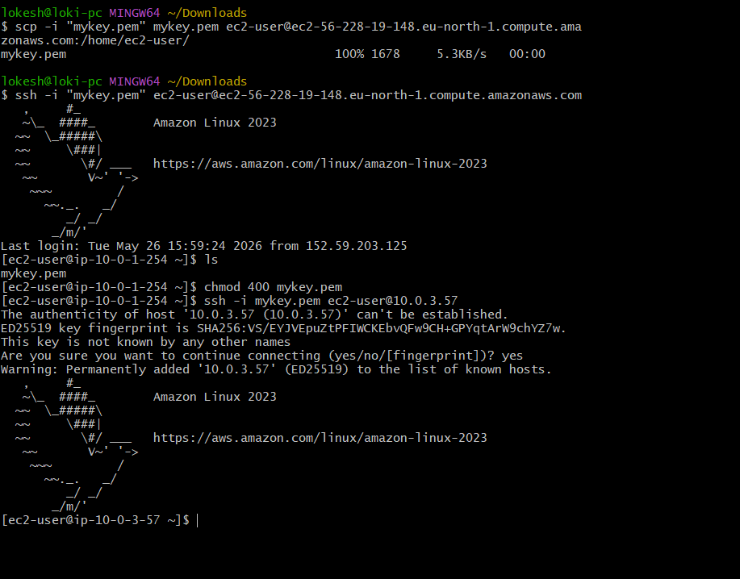
9- Install Apache Tomcat in private EC2 and deploy a sample app.
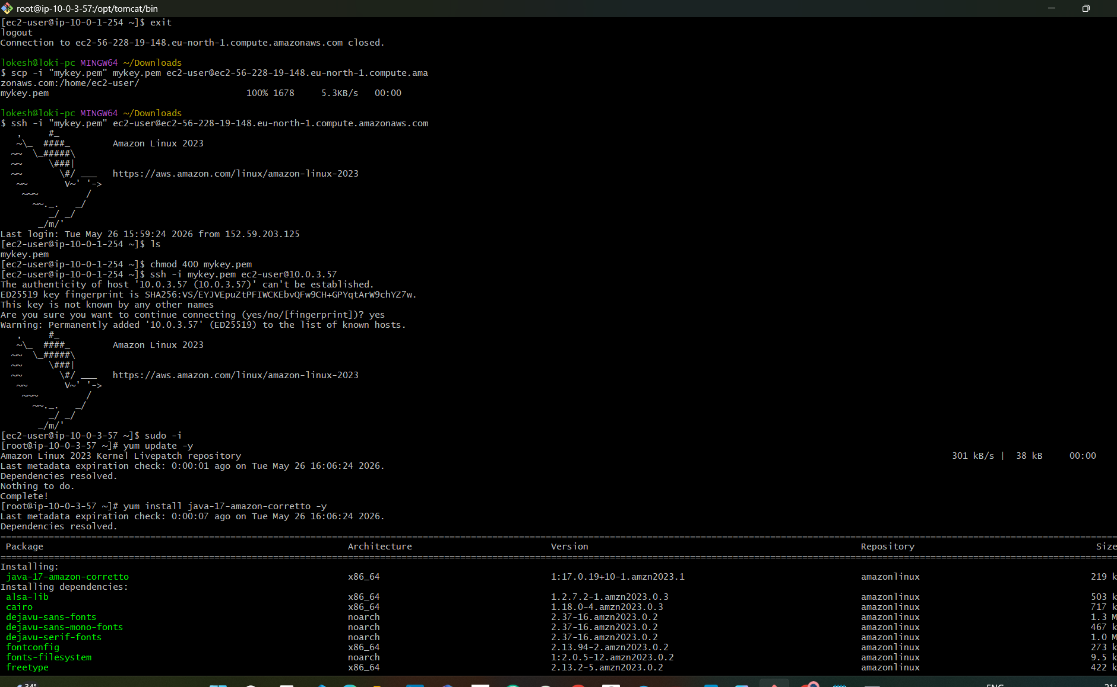 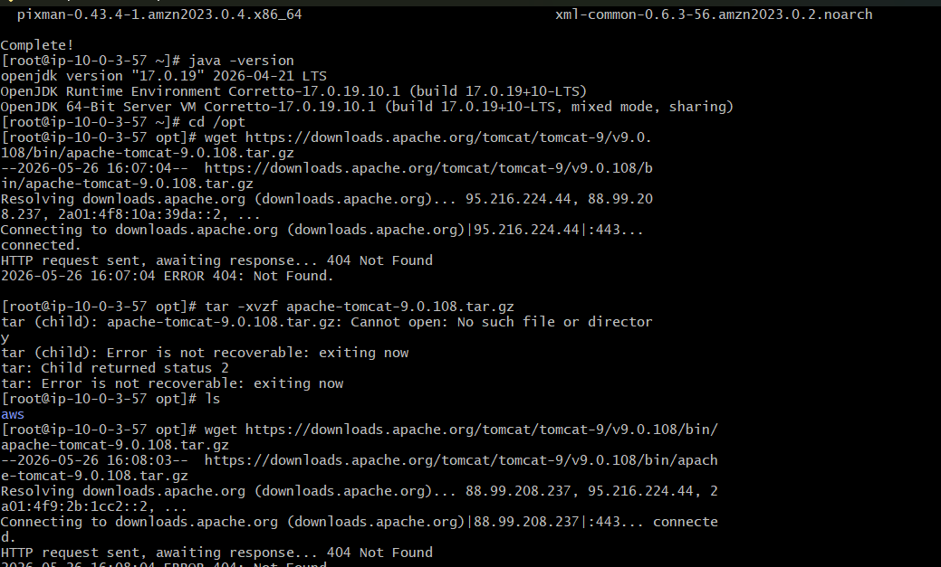 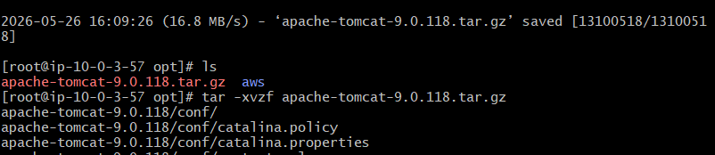v 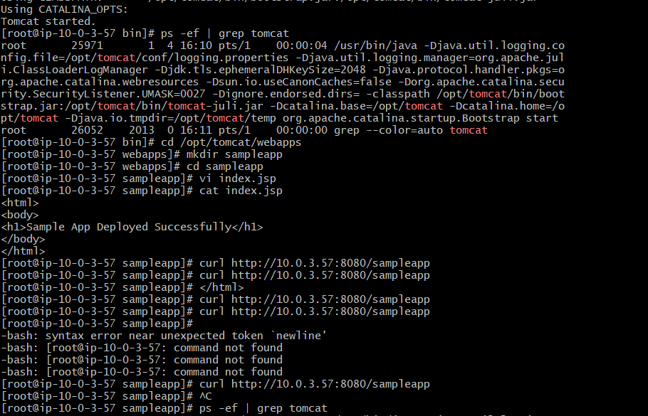 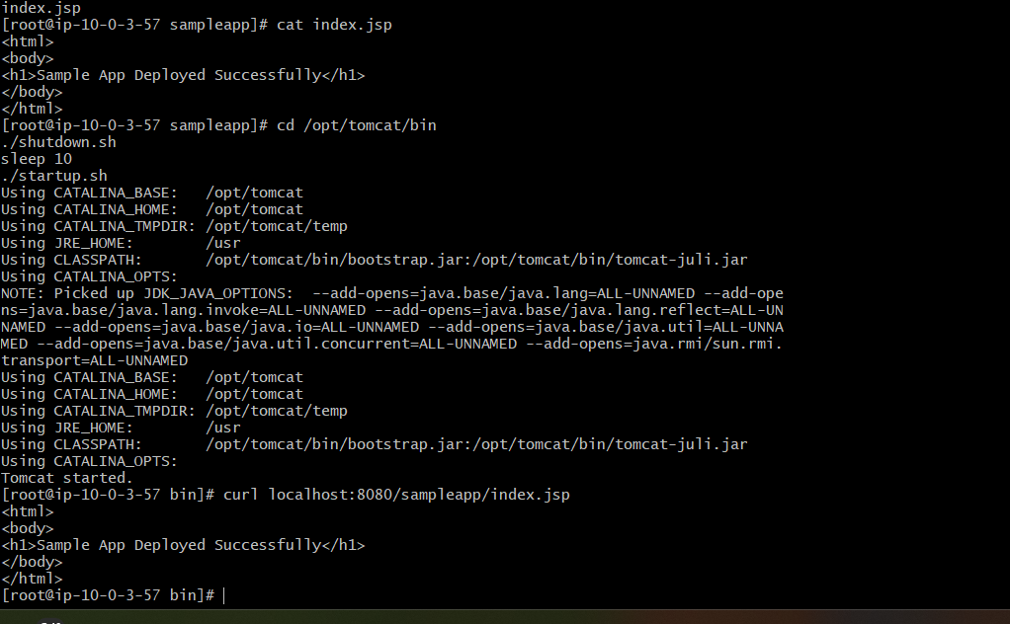 Install Apache Tomcat in Private EC2 and Deploy a Sample Application
Step 1: Connected to the Private EC2 Instance
First, I connected to the private EC2 instance through the public EC2 instance using SSH. This allowed secure access to the private server inside the private subnet.

Step 2: Switched to Root User
After logging in, I switched to root user using:
sudo -i
This provided administrator privileges to install software and configure the server.

Step 3: Installed Java
I installed Java because Apache Tomcat requires Java to run.
I used the package manager to install Java successfully and verified the installation by checking the Java version.
This ensured the server was ready to run Tomcat.

Step 4: Moved to the Installation Directory
I moved to the /opt directory.
This directory is commonly used for installing third-party software like Apache Tomcat.

Step 5: Downloaded Apache Tomcat
I downloaded the Apache Tomcat package from the official Apache server using the wget command.
This downloaded the Tomcat compressed archive file to the server.

Step 6: Extracted the Tomcat Package
After downloading, I extracted the compressed Tomcat archive.
This created the Tomcat installation directory on the server.

Step 7: Renamed the Tomcat Folder
I renamed the extracted folder to tomcat.
This made it easier to manage and access the installation path.

Step 8: Provided Execute Permissions
I moved to the Tomcat bin directory and gave execute permissions to all shell scripts.
This allowed the Tomcat startup and shutdown scripts to run properly.

Step 9: Started Apache Tomcat
I started the Tomcat server using the startup script.
Tomcat launched successfully and began listening on port 8080.
This confirmed the application server was running.

Step 10: Verified Tomcat Process
I verified that Tomcat was running by checking the active processes.
The Java Tomcat process appeared in the output, confirming successful startup.

Step 11: Created the Sample Application Directory
I moved to the Tomcat webapps directory and created a new application folder named:
sampleapp
This folder stores the deployed application files.

Step 12: Created the Sample JSP File
Inside the sample application folder, I created an index.jsp file.
This file contained sample HTML code to display a deployment success message.
This acts as the sample web application.

Step 13: Restarted Tomcat
After creating the sample application, I restarted the Tomcat server.
This allowed Tomcat to load and deploy the new application.

Step 14: Verified Application Deployment
I verified the deployment by accessing:
localhost:8080/sampleapp/index.jsp
The browser output displayed:
Sample App Deployed Successfully
This confirmed that the sample application was deployed and running successfully.

Final Description
I connected to the private EC2 instance, installed Java and Apache Tomcat, configured and started the Tomcat server, created a sample JSP web application, deployed it inside the Tomcat webapps directory, restarted the server, and successfully verified the application deployment. This confirms that the private EC2 instance is running Apache Tomcat and hosting the sample application successfully.

10- Configure VPC flow logs and store the logs in S3 and CloudWatch.

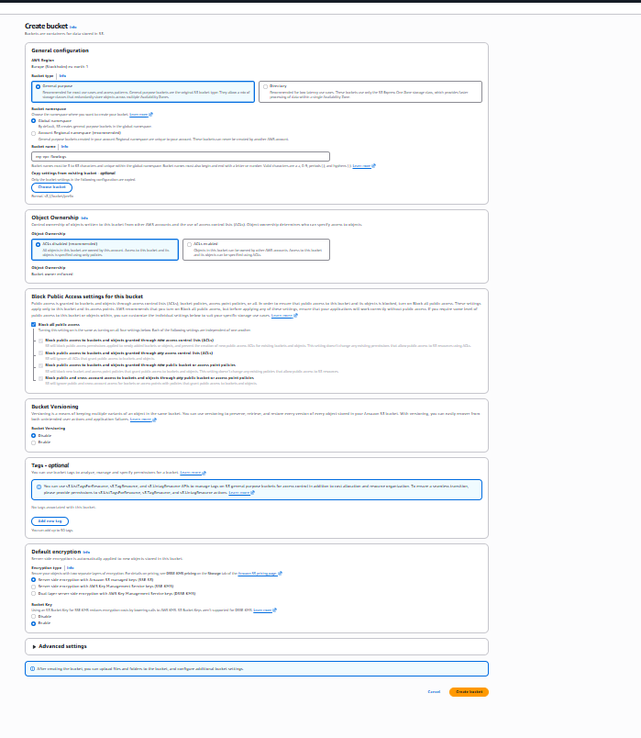 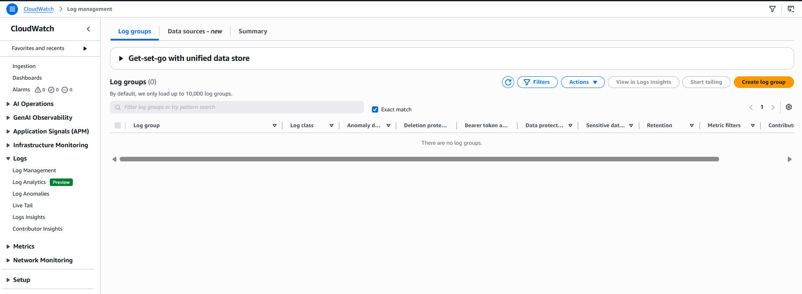 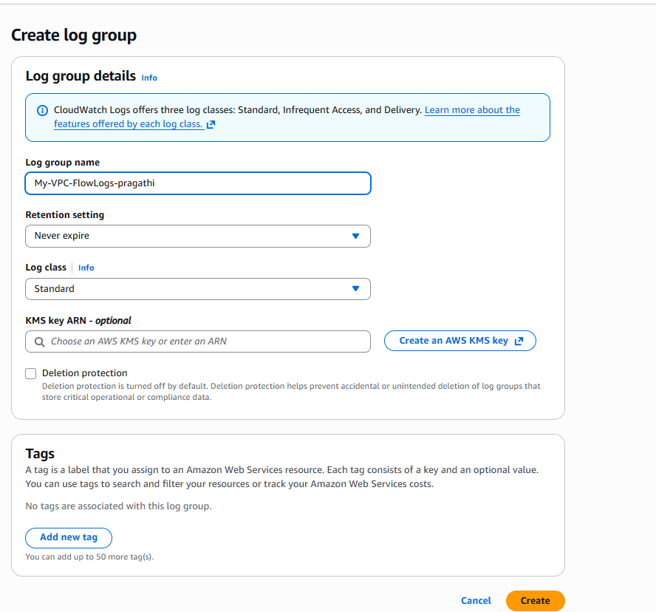 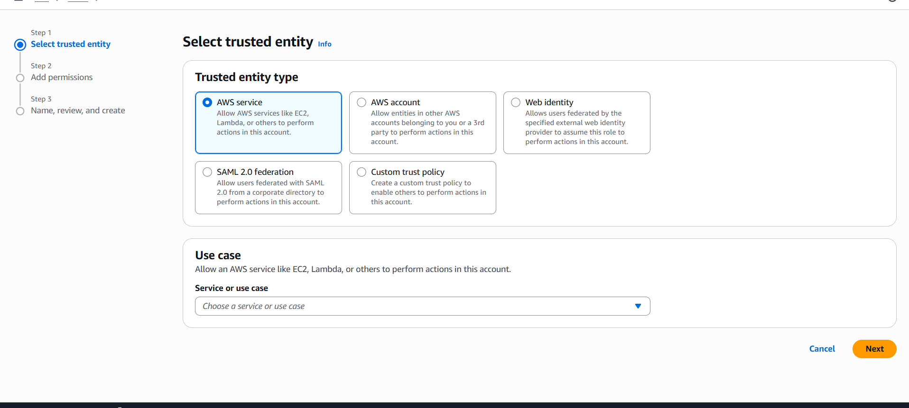 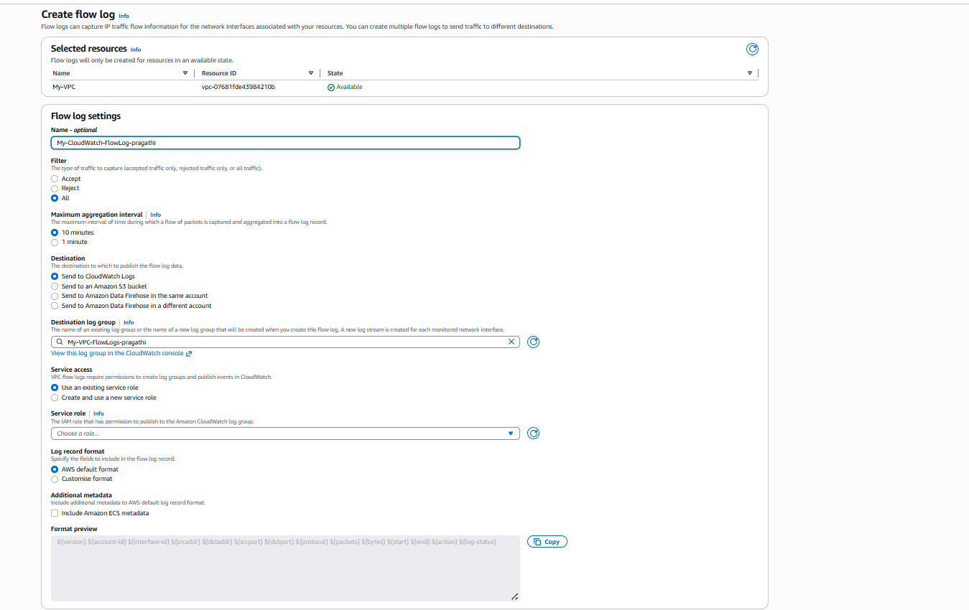 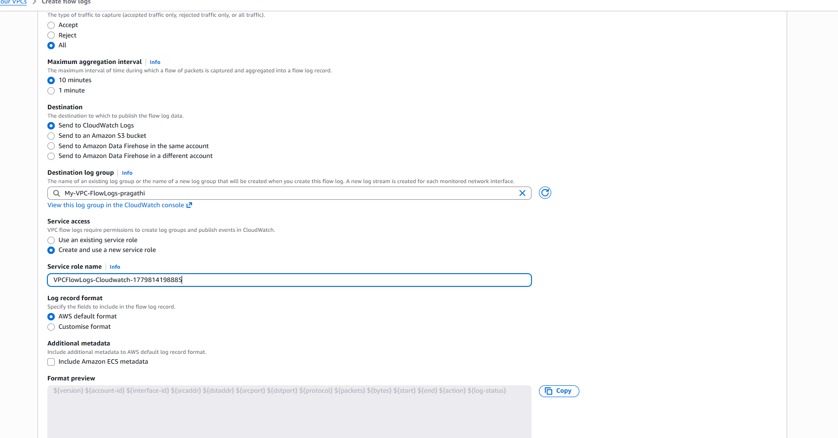 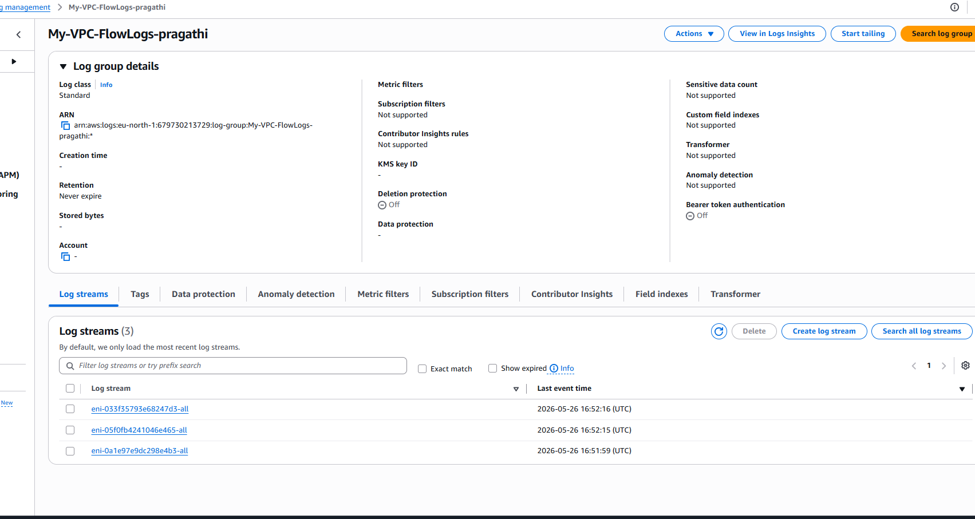 1. Create or Identify Your VPC
First, make sure you already have a VPC.
Steps:
- Go to AWS Console
- Search → VPC
- Click Your VPCs
- Note your VPC ID (example: vpc-0abc123)

2. Create S3 Bucket (for log storage)
We need S3 for long-term storage.
Steps:
- Go to S3 service
- Click Create bucket
- Bucket name: vpc-flow-logs-bucket
- Choose same region as VPC
- Keep:
  - Block Public Access → ON
- Click Create bucket

3. Create CloudWatch Log Group
We need CloudWatch for real-time logs.
Steps:
- Go to CloudWatch
- Click Log groups
- Click Create log group
- Name:
/vpc/flowlogs
- Click Create

4. Create IAM Role for Flow Logs
AWS needs permission to publish logs.
Steps:
- Go to IAM → Roles
- Click Create role
- Select:
  - Trusted entity: AWS service
  - Use case: VPC Flow Logs
- Attach policy:
  - AmazonVPCFlowLogsRolePolicy
- Name role:
VPCFlowLogsRole
- Create role

5. Enable VPC Flow Logs (MAIN STEP)
Step-by-step:
- Go to VPC Console
- Click Your VPCs
- Select your VPC
- Click Actions → Create flow log

6. Configure Flow Log for CloudWatch
Fill details:
- Filter:
All traffic
- Destination:
Send to CloudWatch Logs
- Log group:
/vpc/flowlogs
- IAM Role:
VPCFlowLogsRole
- Click Create flow log

7. Configure Flow Log for S3
Repeat same process OR create another flow log:
Fill details:
- Filter:
All traffic
- Destination:
Send to S3 bucket
- Bucket:
vpc-flow-logs-bucket
- Prefix (optional but recommended):
vpc-logs/
- Click Create flow log

8. Verify CloudWatch Logs
Steps:
- Go to CloudWatch
- Click Log groups
- Open:
/vpc/flowlogs
- You will see:
  - Log streams (ENI-based)
  - Traffic records (ACCEPT / REJECT)

9. Verify S3 Logs
Steps:
- Go to S3
- Open bucket:
vpc-flow-logs-bucket
- Go inside folder:
vpc-logs/
AWSLogs/<account-id>/vpcflowlogs/
- You will see .log.gz files

10. Generate Traffic (IMPORTANT)
Flow logs only appear when traffic happens.
Run in EC2:
ping google.com
curl example.com
Wait 2–5 minutes.

11. Final Result
You will now have:
CloudWatch:
- Real-time logs
- Log streams per ENI
S3:
- Compressed log files
- Stored for long-term analysis

12. Simple Interview Explanation
“I configured VPC Flow Logs at the VPC level and enabled two destinations: CloudWatch Logs for real-time monitoring and S3 bucket for long-term storage. I created IAM role permissions and log groups, then verified logs after generating traffic from EC2.”

